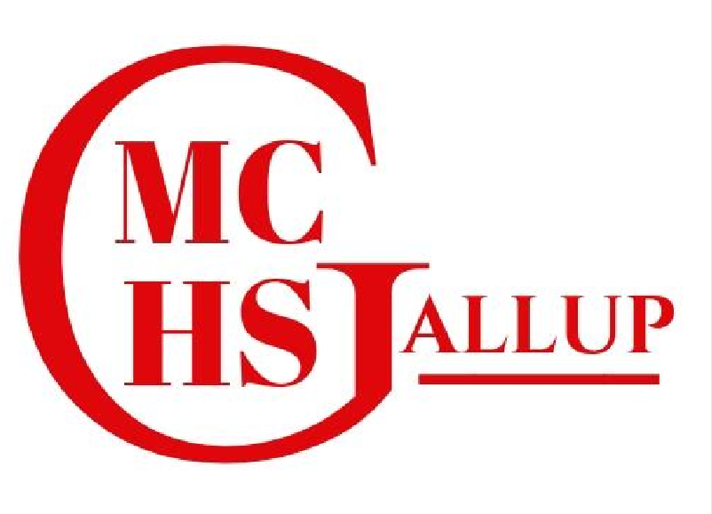
MIDDLE COLLEGE HIGH SCHOOL

Middle College High School Priorities for School Year 2025-2026

In response to feedback received from the annual Stakeholder Input Survey, which includes suggestions from students, parents, and community members, the following three priorities have been identified:

- Stakeholders are overwhelmingly pleased with the overall school culture and “sense of belonging” at Middle College High School. Some respondents, however, identified a desire to expand the school’s club and activity offerings, to offer more days off for culturally specific holidays, and to provide additional language courses.

In addition to clubs such as National Honor Society, the school has implemented an American Indian Science and Engineering Society (AISES) Club. Eighteen students participated in the club’s inaugural season, with the majority of them participating in the Governor’s STEM Challenge. The AISES Club also hosted a STEAM Night in the school’s multipurpose room, which was attended by more than 100 spectators. In response for additional language courses, the school partnered with A:shiwi College to offer a Zuni language course for college credit this school year. In addition, the number of students taking Navajo language has nearly doubled over last year’s course enrollment. As for additional days off in observance of specific holidays, Middle College HS follows the schedule of its host college, the University of New Mexico, Gallup Campus, and is bound by their calendar. Moving forward, the school will continue to investigate additional clubs and activities for student participation.

- Many stakeholders, primarily students, expressed displeasure with the school’s meal service.

Prior to moving into its new facility halfway through the first semester, the school had been utilizing a contractor for meal services. Now in a new building, the school partnered with Navajo Technical University’s Culinary Arts Program to help design and staff its kitchen and food service program. An internationally acclaimed culinary arts program, the school’s meal service has benefitted remarkably from their involvement. Rather than contracting with a separate vendor, the school now employs three cooks who are graduates of Navajo Tech’s award-winning program. Complaints about the quality of the school’s meals are now a thing of the past.

- Stakeholders, particularly parents, are dismayed at the lack of school-based transportation.

The school acknowledges that this has been an ongoing issue for the past six school years. The problem began when the local school district stopped providing transportation to charter school students. The local charter schools filed a lawsuit against the district, but the case has not been resolved. Despite Navajo Nation passing a resolution in support of the school’s right to transportation, New Mexico’s Public Education Department has not enforced the statute that requires local districts to negotiate transportation with charter schools. But with the help of its general counsel, the school has reengaged with the state’s Public Education Department, and discussions regarding the need for transportation services have resumed. The school is working diligently to get this issue resolved and is hopeful that the problem does not continue into the 2026-2027 school year.

UNM GALLUP, 604 SOUTH GURLEY AVE- GALLUP, NEW MEXICO 87301 –www.mchsgallup.com

